Dear Tower Hamlets Development Control,
Site: Bow Wharf, London E3 5SN. Planning application reference: PA/26/01692/A1
The Roman Road Bow Neighbourhood Forum objects to this planning application. Our objection is based on the following material planning considerations and policy conflicts.
The Forum supports new homes at Bow Wharf, and does not oppose development of this site in principle. We ask the Council to refuse this scheme so that a revised one can come forward with more affordable homes, a lower Block D on Grove Road, and substantial leisure, community or employment uses in line with the Neighbourhood Plan.
Summary of objection
1. Affordable housing. The Neighbourhood Forum supports the Council’s commitment to delivering at least 50% affordable housing across new developments. The current application would only provide 20% affordable housing, with 80% being for market sale.
2. Housing Need and Social Infrastructure Pressure. A scheme with 80% private housing fails to address the borough’s acute need for affordable homes, while adding pressure on local infrastructure.
3. Heritage and Design. 2026 National Planning Policy Framework (NPPF): The proposals fail to meet the requirement of policy HE6: Proposals affecting designated heritage assets, and policy HE9: Conservation areas.
The Local Plan policy S.DH1 Delivering High Quality Design and Policy S.DH3 Heritage and the Historic Environment. In the Forum’s view, the development is not of appropriate scale, height, mass, bulk and form in its site context. The proposals also detract from the area’s heritage value. The proposals principally impact the significance of the Regent’s Canal Conservation Area, the Driffield Road Conservation Area and the two locally listed buildings within the site.
4. Amenity. The proposals run counter to Amenity Policy D.DH8, Policy D.CF2 Existing community facilities and Policy D.OWS3 Open space and green grid networks. The proposals would involve the loss of the banqueting venue as a community building, and would reduce the canal side public space around the existing restaurant and bar.
5. Land Use. The proposals focus narrowly on housing provision, and fail to consider the significant opportunities for the long-term development of the site for employment and tourism. They fail to create long-term investment and jobs, protect existing floorspace or encourage the provision of new floorspace, all of which are supported by Local Plan Policy S.EMP1.
6. Loss of employment space. The proposals would remove employment floorspace without the evidence required by Policy D.EMP3. The applicant’s assessment considers only the existing buildings, not the potential of the whole site.
7. Building Strong and inclusive communities. H20 Urban have resisted rather than encouraged early and inclusive engagement under London Plan GG1 and Neighbourhood Plan policy HE1 for Bow Wharf. The developers have also failed to provide for an appropriate mix of uses that include leisure and recreational activities as set out in the Neighbourhood Plan policy HE1.
Detailed supporting evidence
1. Affordable Housing and Tower Hamlets Policy
Whilst the application meets the minimum 20% level of affordable housing under the GLA’s 2026 short-term emergency guidance, Support for Housebuilding, this is far below the 35% minimum requirement under the Tower Hamlets Policy D.H2 on affordable housing for sites providing 10 or more homes. The S.H1 housing policy expectation of a minimum 35% affordable housing on sites providing 10 or more homes is endorsed in paragraph 3.31 of the Mayor’s Accelerated Housing Programme (MAHP) Cabinet report (15 July 2026). Whilst the current application is not an MAHP site, MAHP provides the wider policy context for the Bow Wharf proposals.
1.1 London Plan Housing Policy. Policy H5 Threshold Approach to Applications remains in place alongside the temporary measures in the ‘Support for Housebuilding’. The policy states: ‘B The threshold level of affordable housing on gross residential development is initially set at a minimum of 35 per cent;’
These are material planning considerations because the principle of development must comply with Development Plan policies. Failure to meet minimum affordable housing thresholds is grounds for refusal. Approving a scheme with only 20% affordable housing would set a harmful precedent that undermines the borough’s ability to secure affordable housing on other sites.

2. Housing Need and Social Infrastructure Pressure.
A scheme with 80% private housing fails to address the borough’s acute need for affordable homes. This is a material planning consideration under infrastructure capacity and housing need.
2.1 Tower Hamlets has one of the highest levels of housing need in London, and the highest waiting list for social housing in the UK (2023 Local Housing Needs Assessment).
A scheme with 80% private housing fails to address this acute need and places additional pressure on local social infrastructure (schools, GP surgeries, transport), contrary to the Local Plan’s housing and infrastructure policies.
3. Heritage and Design
The proposals fail to meet the requirement of Policy HE6 and policy HE9 of the 2026 National Planning Policy Framework (NPPF).
The Local Plan policy S.DH1 Delivering High Quality Design requires that the highest standards of design and layout respect and positively respond to the site’s context, townscape, landscape and public realm, including the character of the local setting.
3.1 August 2026 National Planning Policy Framework (NPPF). Policy HE6 requires substantial weight must be given to an asset's conservation when evaluating development proposals, with greater weight applied to more important assets—regardless of whether the impact is positive, harmful, or results in a total loss.

Policy HE9 For conservation areas, the policy says development within or affecting the significance of a conservation area should:
- retain and conserve buildings and other features which make a positive contribution to its character or appearance where possible
- consider the area’s special architectural or historic interest in the design of development
Impact on Setting: The scale and positioning of the two new residential blocks fail to respect the character of the surrounding Conservation Areas, thereby harming the setting of the heritage assets.
Public Benefit Balance: While housing is a public benefit, this is limited, as 80% of the proposed homes would be for market sale, and the benefit does not automatically override heritage protections. The public benefits of this specific layout do not meet the "substantial weight" threshold required to justify the permanent harm to the canal's historic environment.
3.2 Conservation areas. The 2025 Heritage, Townscape and Visual Statement by Turley Heritage emphasises the significance of the Regent’s Canal Conservation Area: ‘The adopted Regent’s Canal Conservation Area Character Appraisal and Management Guidelines document provides a summary of the special interest of the area. It states that: “The Regent’s Canal and the western part of the Hertford Union Canal is a remarkable early 19th century civil engineering achievement. It represents both an important industrial heritage and a public amenity. This is an area of particular special architectural and historic interest, worthy or protection. The character and appearance of the area, as described in this appraisal, define its special qualities.’’ ‘ (p.25).
3.3 Statutory duties. The statutory duties of the Planning (Listed Buildings and Conservation Areas) Act 1990 provide the key requirements which need to be met: Part 2 includes the requirement to have special regard to the desirability of preserving the listed building or its setting or any features of special architectural or historic interest which it possesses, and to pay special attention to preserving or enhancing the character or appearance of conservation areas. The NPPF confirms the statutory protection which is afforded to heritage assets and requires great weight to be attached to an asset’s protection.
3.4 Heritage value The heritage value of the site was highlighted in the East End Waterways objection to the 2025 application.
East End Waterways Group argued that the new blocks would add nothing of architectural or historic interest to the conservation area, and that Blocks B and D would largely block the important views between Wennington Green, the Hertford Union Canal and the Victorian terraces on Old Ford Road overlooking Victoria Park.

The purpose of the 2019 heritage appraisal commissioned by H20 Urban was to assess the scope for development of the site. It summarised the likely impact of development proposals in the paragraph and table below. The appraisal said: ‘8.4 Given the nature of the Site and emerging proposals, it is likely that new development has the potential to principally impact the significance of the Regent’s Canal Conservation Area; and the two locally listed buildings within the Site; and the Driffield Road Conservation Area.’

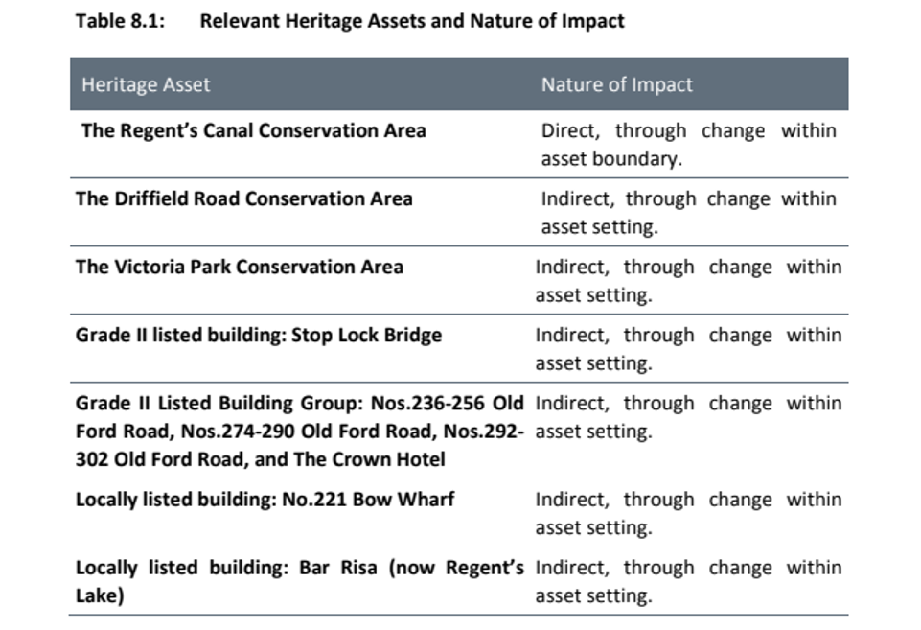

3.5 Local Policy and Design. Policy S.DH1: Delivering High Quality Design, stipulates that development is required to meet the highest standards of design, layout and construction which respects and positively responds to its context, townscape, landscape and public realm at different spatial scales, including the character of the local setting to which it is set. To achieve this ‘development must be of an appropriate scale, height, mass, bulk and form in its site context.’
The Forum disagrees with the view expressed by the Council in 2025 that: ‘The scale, height and massing of the buildings, between 4 to 6 storeys, is appropriate to the surrounding context.’
The 2019 Turley heritage appraisal stated regarding feedback on scale:
‘8.8 This feedback also indicates that a building of 3-4 storey scale may be acceptable in this location, depending on how it integrates with the existing, locally listed buildings on site.’
This conflicts with Turley Heritage’s later 2025 conclusion in its Heritage, Townscape and Visual Statement, that ‘The visual assessment demonstrates that the mass and height of the Proposed Development, and particularly of the new built form within the Site (Buildings B and D) is in-keeping and of a similar scale to the locally listed buildings within the site, such that the Proposed Development would sit comfortably within the existing townscape context.’ (p.105-6)
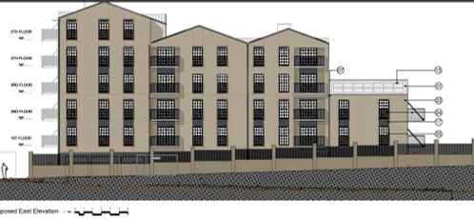
The drawing above shows the proposed 3-6 storey block D along Grove Road (Maximum height 21.4 metres)
The policy further places significant weight on the protection and enhancement of conservation areas and their setting , with development required to preserve or enhance their character or appearance.
3.6 Local Heritage Policy S.DH3 Heritage and the Historic Environment requires ‘Proposals to alter, extend or change the use of a heritage asset or proposals that would affect the setting of a heritage asset will only be permitted where: a. they safeguard the significance of the heritage asset, including its setting, character, fabric or identity b. they are appropriate in terms of design, height, scale, form, detailing and materials in their local context c. they enhance or better reveal the significance of assets or their settings.’
The Turley 2019 heritage appraisal cited above and table 8.1 indicate the nature of the impact on heritage assets, particularly on the Regent’s Canal Conservation Area, and calls into question the proposed 3-6 storey Block D on Grove Road, suggesting a 3-4 storey building would be more appropriate.
4. Amenity
The proposals run counter to Amenity Policy D.DH8, Policy D.CF2 Existing community facilities and Policy D.OWS3 Open space and green grid networks
4.1 Local Plan Policies.
Amenity Policy D.DH8,( p.67) says: ‘Development is required to protect and where possible enhance or increase the extent of the amenity of new and existing buildings and their occupants, as well as the amenity of the surrounding public realm.’
Policy D.CF2 Existing community facilities, (p.130) requires that ‘existing community facilities must be retained unless it can be demonstrated that:
a. there is no longer a need for the facility or an alternative community use within the local community, or
b. a replacement facility of similar nature that would better meet the needs of existing users is provided.’
The banqueting venue was a popular venue before the pandemic. It has strong potential, either for community and/or small business use to complement the neighbouring facilities of the nearby local gym, restaurant and bar. It has not been demonstrated that there is no longer a need for the facility. The public amenity of the banqueting venue will be lost if converted into a private residential development. It has not been demonstrated that points a and b above have been met, and there is a growing need for community facilities in Bow, given the growing population.
Policy D.OWS3 Open space and green grid networks
‘4. Development should not adversely impact on the public enjoyment, openness, ecological and heritage value of the borough’s publicly accessible open spaces.’
The new housing blocks, the reduced public space and the demolition of the Canal & River Trust office would permanently harm the setting and public enjoyment of the canalside, including the restaurant’s outdoor seating and the adjacent bar, which together form one of the site’s main publicly accessible spaces. The new site entrance would sit immediately beside the restaurant. If the Council is minded to approve the application, the Forum asks that a construction management plan be secured by condition to protect these businesses during the two-year build.

5. Land Use.
The proposals focus narrowly on housing provision and fail to consider the very significant opportunities for the long-term development of the site for employment and tourism. They fail to create long-term investment and jobs, protect existing floorspace or encourage the provision of new floorspace, all of which are supported by Local Plan policy S.EMP1.
5.1 Local Plan policy S.EMP1, Creating investment and jobs ‘4. Proposals will be supported which provide opportunities to promote the creation of a sustainable, diverse and balanced economy through: a. ensuring availability of a range of workspaces and unit sizes, start-up space, co-working space and ‘grow-on’ space by protecting existing floorspace and encouraging the provision of new floorspace,..’
5.2 Future potential for mixed use development. The current application does not consider the wider land-use potential of developing the site for a mix of uses, including the creative industries, commerce, community use and tourism, despite the evidence of thriving nearby canal-side locations such as the food market in Victoria Park, and restaurants, bars and markets around Hackney Bridge.
The consistent policy of the Canal and River Trust for over 20 years has been to move away from the site’s historic industrial and more recent mixed industrial (brewing), commercial and leisure uses, towards mainly private housing. This has been driven in part by the Canal & River Trust’s reliance on property development to compensate for falling government funding. This change is reflected in recent planning applications:
2002 planning application for 34 housing units refused, both initially, and on appeal.
2011 application (PA/11/03372) for 34 housing units initially refused, but allowed on appeal.
2025 application (PA/25/00557/A1) for 66 housing units and 1 commercial unit. Application refused.
The narrow focus on housing development has meant the potential for the site to be developed for mixed employment and leisure uses has not been adequately explored. This potential was considered in previous studies:
The 2019 Turley heritage report was positive about the potential for a new mix of uses ‘to make the most of this special location.’
It included the following: ‘8.9 The Design Feasibility Study, prepared by Savills and dated May 2018, illustrates the intention to pursue a regeneration of the site that incorporates a mixture of commercial workspace; retail and restaurant uses; leisure functions; and residential accommodation.’
‘8.18 There is a positive / supporting policy context for the incorporation of a new mix of uses in developments adjacent to the Regent’s Canal, to make the most of this special location. There is also strong potential, in heritage terms, to introduce new uses to the site which can better-reveal the significance of the two locally listed buildings within the site, and the surrounding Regent’s Canal Conservation Area:
• Potential leisure / community uses would be supported in heritage terms, as this is consistent with established uses and the prevailing character along the canal, as found today.’
The 2025 East End Waterways Group’s letter of objection suggested some possible alternative uses for the Regent’s Lake banqueting building:
‘To help towards resolving the conflict at very little cost, the sympathetically-adapted c.1907 warehouse (with its substantial 1996-inserted internal frame providing a two-storey-high, four-bay hall) could very readily be re-used for indoor sports, such as badminton in the hall and snooker and darts elsewhere in the building. Or it could be re-used as a business centre (like the one in Dod Street on the Limehouse Cut).’ (p.11)
5.3 The H20 Urban Planning Statement. This acknowledges the centrality of mixed use, including leisure, on the site: ‘Key to the proposals is the creation of a mix of uses set around a public space, focused on the waterside setting. The retention of the leisure uses, supports the creation of a destination which will be attractive to the public and create a vibrant location set around high quality public open space. The desire to incorporate a mix of uses has been central to the scheme from the beginning and whilst viability is challenging, the inclusion of an additional commercial unit on the Grove Road/Wennington Road corner helps to expand the public areas outside of the main square, providing activity on the edge of the site, animating the area around the entrance.’ (p.22)
5.4 Lack of Public Amenity. The addition of 66 flats does not support ‘the creation of a destination which will be attractive to the public and create a vibrant location.’ The proposed new block D would very significantly restrict the amount of public space. The new public space between building C (Pure Gym), and the block D along Grove Road, is very restricted. This is shown in the site plan below. Buildings C and D would very much enclose and dominate the space.
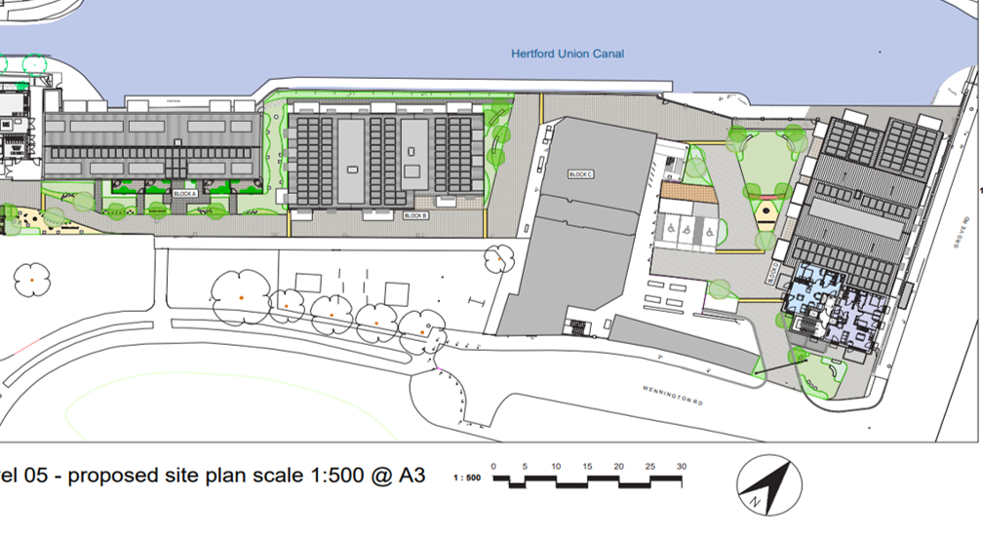
The H20 Urban Planning Statement says (p.34): ‘The proposals are focused around high quality open space and new canal side setting………... The result is a development with open space central within the design, creating a high quality environment for residents. The use of large balconies and patio areas provide quality private space for residents.’ This highlights that the emphasis is on the quality of the environment for residents rather than on wider public benefit.
6. Loss of Employment space.
The proposal would represent a major loss of employment floorspace on the site, which cannot be justified in accordance with Policy D.EMP3, Loss of Employment Space, and S.EMP1, Creating Investment and Jobs . The information provided is insufficient to persuade that the site is genuinely unsuitable for continued employment use, nor has it been robustly demonstrated that new employment uses could not be incorporated into the future development of the site.
6.1 2026 National Planning Policy Framework (NPPF) While the 2026 NPPF places substantial weight on the use of brownfield land for housing, its newly structured economic section (Chapter 7: Building a strong, effective economy), requires development plans to have a proactive and realistic approach to encouraging sustainable economic growth.
E1: Providing the conditions for long-term economic growth
‘1. To support business investment and employment, development plans should, at the most appropriate level:
a. Set out a clear economic vision and strategy, which takes a positive, proactive and realistic approach to encouraging sustainable economic growth in both urban and rural areas, having regard to the Industrial Strategy and any relevant strategic and local strategies for economic development and regeneration.’
6.2 Local Policies. Local Plan Policy S.EMP1, Creating investment and jobs ‘4. Proposals will be supported which provide opportunities to promote the creation of a sustainable, diverse and balanced economy…’
Local Plan Policy D.EMP3 Loss of Employment Space. The application focuses on existing buildings rather than the site, and does not comply with either the policy requirement to:
- a. provide evidence of active marketing over a continuous period of at least 24 months at a reasonable market rent which accords with indicative figures,
- or b. provide robust demonstration that the site is genuinely unsuitable for continued employment use due to its condition; reasonable options for restoring the site to employment use are unviable; and that the benefits of alternative use would outweigh the benefits of employment use.

The policy explanation includes: ‘10.31 It should be demonstrated that the proposed development would not prejudice wider land-use objectives…’
6.3 H20 Urban’s Focus on Existing Employment Floorspace. The H20 Planning Statement says: ‘It is recognised that the previous planning application was refused in part due to perceived conflict with policy D.EMP3 through the removal of commercial floorspace on the site to facilitate redevelopment. In order to address this issue an assessment has been undertaken by Dobbin & Sullivan which examines more closely the commercial viability, market attractiveness and long-term sustainability of the existing employment floorspace within the site.’ (p.26)
Both the 2025 ‘Statement on Loss of Employment Floorspace’ and the July 2026 Dobbin & Sullivan Bow Wharf Employment Land Commercial Market Assessment mainly focus on the three timber pavilions and Regent Lake banqueting venue, and fail to consider the long-term potential of the whole site for future employment, including combining commercial use with leisure and tourism.
The Dobbin & Sullivan July 2026 ‘Bow Wharf Employment Land Commercial Market Assessment’ said :‘Our assessment concludes that the Pavilion Units, together with Block A, have reached a stage within their investment lifecycle where increasing capital expenditure is required simply to preserve their existing function rather than materially improve their commercial performance.’ (p.26)
6.4 Running down of Banqueting Venue (Block A). Paragraph 2.11 of the March 2025 Financial Viability Assessment states concerning the Regent Lake banqueting building (Block A) : ‘The warehouse building is occupied at a low passing rent of £12,000 per annum (£1.57 per sq.ft.) owing to the site being prepared for redevelopment and the tenant historically being on a COVID-19 recovery payment plan.’
The banqueting venue has been allowed to run down in view of the present planning application. The Cherryman report, on the ‘Commercial Use Viability’ of the locally listed banqueting venue says Bow Wharf is comparable to South Quay as a commercial market in East London. South Quay, however, is a very different area, with a very different history and current use.
6.5 Forum View On Loss Of Employment Space. The Forum disagrees with the Planning Statement that denies the proposals involve a loss of employment space. This statement says: ‘The proposals should not be considered as the loss of employment, but as the managed replacement of increasingly obsolete accommodation with a strategy that supports the continuation of employment in premises better aligned with the future needs of East London's commercial market.’(p.28)
The applicant has not demonstrated for the site that ‘re-provided employment space as part of redevelopment would not be viable.’ Further, the demolition of the Canal & River Trust office is itself a loss of employment space that the application does not acknowledge.
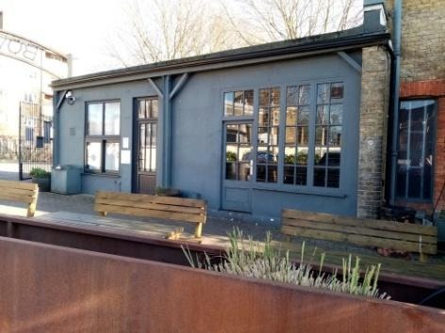
The Turley Heritage 2025 report minimises the loss: ‘The demolition of the single-storey brick structure in the south-west corner of the site will not cause heritage harm or adversely impact on townscape or visual amenity.’ (p.74)This appears to describe the Canal & River Trust office, which is in fact in the south-east of the site.

Image of the Canal & River Trust office proposed
for demolition. This adjoins the restaurant.

7. Building Strong and inclusive communities
H20 Urban have resisted rather than encouraged early and inclusive engagement under London Plan GG1 and Neighbourhood Plan policy HE1 for Bow Wharf. They have also failed to provide for an appropriate mix of uses that include leisure and recreational activities, as set out in the Neighbourhood Plan.
7.1 London Plan London Plan Policy GG1 seeks to build strong inclusive communities including through requiring:
A. encourage early and inclusive engagement with stakeholders, including local communities, in the development of proposals, policies and area-based strategies
B. seek to ensure changes to the physical environment to achieve an overall positive contribution to London
C. provide access to good quality community spaces, services, amenities and infrastructure that accommodate, encourage and strengthen communities, increasing active participation and social integration, and addressing social isolation
7.2 Lack Of Inclusive Engagement The Canal & River Trust has pursued a practice of only sharing the minimum amount of information with the public. It withheld the 2019 heritage appraisal for Bow Wharf, which is directly relevant to this application, until July 2026. It released the appraisal only after the Information Commissioner issued a Decision Notice against it in October 2025 and the Trust withdrew its appeal the day before the Tribunal hearing.
This letter notifying neighbours of the proposal gave just three weeks for people to respond, and there was no in-person or online opportunity to engage directly with H20 Urban or their architects.
7.3 Roman Road Bow Neighbourhood Plan
The Roman Road Neighbourhood Plan was adopted in 2022 after a local referendum, and forms part of the Development Plan for Tower Hamlets alongside the Local Plan and London Plan. Policy HE1 of the plan relates specifically to Bow Wharf. This recognises the heritage value of the site and requires proposals for development on the site to respect the heritage value and enhance its historic significance and cultural vibrancy. Proposals are required to include a statement of heritage significance to show how the proposals positively reflect and are informed by the historic context.
Policy HE1 Bow Wharf Waterway Infrastructure Conservation And Enhancement ‘Developers are advised to ensure plans are developed in consultation with the Council’s conservation team, Neighbourhood Forum and the Canal and River Trust. Proposals must demonstrate widespread consultation with local businesses, residents and community groups.’
7.4 Mix of Uses. The specific policy for Bow Wharf says:’ Development proposals must provide for an appropriate mix of uses that include leisure and recreational activities and, where workspaces are provided as part of redevelopment, affordable workspaces for small businesses should be provided in line with the Local Plan. Recreational provision that improves connectivity with the Green Grid and better links Victoria and Mile End Parks and/or Hackney Village with the Roman Road, will be strongly supported.’
Neither the 2025 nor the current proposals include any new leisure or recreational provision, despite the explicit encouragement to provide this and improve connectivity and better links with Victoria and Mile End Parks and/or Hackney Village with the Roman Road.
For these reasons, the Forum asks the Council to refuse this application. We would welcome the opportunity to work with the Council, the Canal & River Trust and H20 Urban on a revised scheme that meets the Development Plan and the needs of the local community.
Yours faithfully,
Mike Mitchell, Secretary, on behalf of The Roman Road Bow Neighbourhood Forum
2nd November 2026

